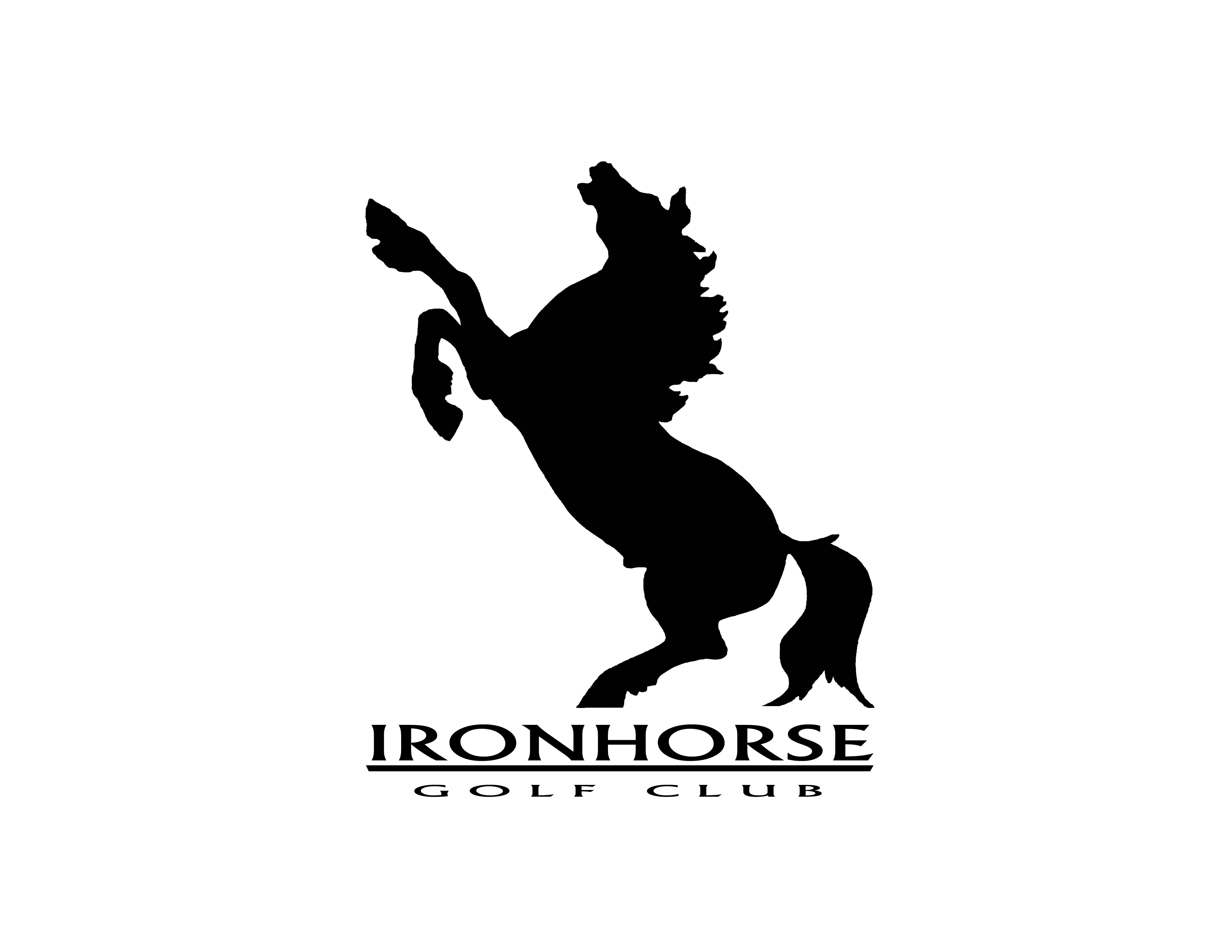

Event Agreement

Rental Rate: Price is dependant upon day, size, type and duration of your event.

Date of Event: Starting Time:

Name of Event:

Type of Event:

Number of People: ___________ (must be confirmed 5 days prior to the event)

Ironhorse Golf Club will provide your group with the following for your event:

Tables / Chairs, Bar Service, Set-up assistance, Clean-up service

Please check the following optional items that apply to your event, please check all that apply:

Cash Bar _____ Open Bar _____

Table Linens _____ Bartender _____

Special Requests: ___________________________________

___________________________________

Rules & Regulations

- All beverages must be purchased from Ironhorse Golf Club.
- Confirmed counts are final 5 days prior to the event.
- A deposit is required required to hold all events. PAYMENT IN FULL is due on the day of the event.
- Ironhorse reserves the right to refuse service to anyone for improper behavior; such refusal will occur without refund.
- All bar minimums agreed upon prior to the event must be met.

The event host / chairman will be held responsible for all damages to Ironhorse Golf Club property.

In connection with the event described above, the chairman agrees to indemnify and hold harmless Ironhorse Golf Club from any claims or liability arising out of any actions or omissions of any of the chairman’s guests, either on of off the premises of Ironhorse Golf Club.

I agree to the above conditions and policies and agree to abide by the rules of Ironhorse Golf Club:
Event Chairman: Name, address, and phone

Event Chairman Signature Date Signed

